Testing for Bubbles in Housing Markets: New Results Using a New Method

José E. Gómez-González
Jair N. Ojeda-Joya
Catalina Rey-Guerra
Natalia Sicard

ABSTRACT
In the context of financial crises influenced by the development and burst of housing price bubbles, the detection of exuberant behaviors in the financial market and the implementation of early warning diagnosis tests are of vital importance. This paper applies the new method developed by Phillips et al (2012) for detecting bubbles in the Colombian residential property market. The empirical results suggest that currently the country could be experiencing a price bubble, when the CPI and the housing rent index are used as deflators. We do not check the robustness of these results to alternative deflators, such as a household income index and a land price index, due to the lack of monthly data on these indicators.
JEL Classification: C22, G12, R31
Keywords: Housing-price bubbles; Unit-root tests; Colombia

- Introduction
Financial crises and asset price bubbles are strongly connected. Many financial crises have followed episodes of exuberant price increases in real and financial assets. Traditional examples include the Dutch Tulipmania, and the 1929 Great Crash in the United States. During the seventeenth century Dutch Tulipmania, extremely rapid price increases in tulips motivated people to buy tulip bulbs on credit with the hope of making instant fortunes. A single bulb of the “Semper Augustus”, one of the priciest types of tulips, cost 13,000 guilders, more than many first-class houses in Amsterdam. However, by 1637 the tulip price bubble crashed and many market participants went bankrupt. The history of the 1929 crisis is not that different, although no tulips were involved in it.
More recent examples of asset price bubbles include Japan in the late 1980s and early 1990s, several Latin American economies in the 1980s, South East Asian Economies in the late 1990s, the Mexican Tequila crisis, Russia in the late 1990s, and an important group of industrialized economies in the recent international financial crisis.
Rational or not, asset price bubbles typically have common features. In a first stage, ample credit expansion accompanied by sustained increases in asset prices, such as stocks and real state, inflate the bubble. In a second stage, the bubble bursts and asset prices collapse as short-sales abound. Sufficiently large bubbles lead to the default of many agents who had borrowed to buy assets at historically high prices. Banking crises may follow agents’ defaults.
Given its importance, price bubble detection has been widely studied in the literature. The most commonly used detection methods follow the present value model under the assumption of rational bubbles. Early proposals include Shiller’s variance bound test (Shiller, 1981), and West’s two step test (West, 1987). Campbell and Shiller (1987) and Diba and Grossman (1988) introduced the (perhaps) most commonly used methods for detecting asset price bubbles in the literature, namely the right-tailed unit root test and the cointegration test. These two tests have been extensively used to detect stock price bubbles and housing price bubbles over the last two decades (for instance, see Drake, 1993; Arshanapalli and Nelson, 2008; Salazar et al, 2013).
These two frequently used methods, however, suffer from a serious limitation that was first pointed-out by Evans (1991), who showed that these tests are not able to detect explosive bubbles when the sample data includes periodically collapsing bubbles. Different alternatives have appeared in the literature to deal with Evan’s critique. In a recent paper, Phillips et al (2011) propose a supremum Dickey-Fuller (DF) test that overcomes the problem identified with unit root and cointegration tests. The supremum DF test improves power significantly with respect to the conventional unit root and cointegration tests, and has the advantage of allowing estimation of the origination date and final date of a bubble. The method presents a limitation, though: it is designed to analyze a single bubble episode. Most interesting datasets, however, include multiple bubbles. To overcome this shortage, Phillips et al (2012) generalized the methodology and proposed a supsup Dickey-Fuller (GSADF) test for detecting multiple bubbles.
The method proposed by Phillips et al (2012) was used by Yiu et al (2012) for detecting bubbles in the Hong Kong residential property market. Interestingly, they find striking results that significantly contrast with earlier papers on Hong Kong’s housing market.
In this paper we present a second application of this newfangled method, using monthly data for the Colombian housing market between 1994:1 and 2012:8. The case of Colombia is an interesting one to analyze due to different motives. First, Colombia experienced a deep financial crisis in the late 1990s after a period of financial liberalization. This financial crisis was widely attributed to a housing price bubble which followed the financial liberalization process of 1991. Second, during the last few years, housing prices (as well as stocks’ prices) have steadily grown in the country, motivating a heated debate on whether or not Colombia is experiencing a new housing price bubble. Finally, in contrast to earlier papers that use Colombian data, we find that currently the country could be experiencing a residential property market price bubble.
Some caveats apply to our results. First, we are not able to check the robustness of our results to alternative deflators, such as a household income index and a land price index, due to the lack of monthly data on these indicators. And, second, in this study we implement a univariate detection test which does not consider a structural model of supply and demand for housing. Following the tradition of unit-root and cointegration tests, the methodology we implement works under the I(1) null hypothesis based on the theory of efficient markets, where asset prices follow a random walk reflecting the assumption that only new information affects each period’s current asset prices. We acknowledge that methodologies based on alternative theories should be considered in order to confirm the results shown in this paper.
Section 2 makes a brief presentation of the methodology used in this study and its advantages with respect to alternative methods. Section 3 presents some stylized facts of the Colombian housing market. Section 4 presents the empirical results, and finally Section 5 concludes.

2. Econometric Methods
We use a new recursive procedure which allows testing, identifying and date stamping explosive bubbles in economic time series. This econometric method is developed by Phillips et al (2012) and its purpose is serving as an early warning system. It is assumed that prices of financial assets are subject to pricing errors and/or time-varying discount factors which induce the formation of financial exuberance through price bubbles.
This method is based on the DF unit root test which, in its simplest form, follows this regression:
$∆p_{t}=μ+\left(ρ-1\right)p_{t-1}+ε_{t}$, (1)
where $p_{t}$ is the real price of the asset and $ε_{t}$ is the error term. The null hypothesis is unit-root behavior $\left(H_{0}:ρ=1\right)$ and the alternative hypothesis is explosive behavior$\left(H_{1}:ρ>1\right)$. Notice that this alternative hypothesis is different to the usual one on left-tailed unit-root tests $\left(H_{1}:ρ<1\right)$.
The right-tailed DF statistic is computed in multiple recursive regressions in which the number of observations is varying as well as the initial observation for each regression. The GSADF statistic (with respect to the number as well as the alternative initial observations) is then used to detect the presence of at least one bubble in the whole sample. In order to estimate the origination and collapse dates of every bubble, a sup DF statistic with respect to the number of observations is computed for each alternative last observation in every regression. The resulting series of DF statistics is then compared with an appropriate series of critical values.
Let $r_{0}$ be the fraction of the sample that corresponds to the minimum number of observations used in each regression. Furthermore, let $r_{2}$ be the fraction corresponding to the last observation used in the regression. Finally, let $r_{w}≥r_{0}$ be the fractional window size of the regression and n the total sample size. Therefore, the DF test statistic obtained in a regression starting in fraction $r_{2}-r_{w}$ and ending in fraction $r_{2}$ is the following:
$DF_{r_{2}-r_{w}}^{r_{2}}=\left[nr_{w}\right]\left(\hat{ρ}-1\right)$, (2)
where $\left[∙\right]$ represents the integer part. Additionally, the supsup test statistic can be defined as follows:
$\operatorname{GSADF}{=sup_{r_{w}}} sup_{r_{2}}DF_{r_{2}-r_{w}}^{r_{2}}$. (3)
Phillips et al (2012) derive the limit distribution of the GSADF statistic which is a non-linear function of $r_{0}$ and Brownian motions. Using this result and Montecarlo simulation methods, it is possible to compute both asymptotic and finite-sample critical values.
The methodology for time stamping bubbles consists of computing a series of sup DF statistics which are defined in the following way:
$BSDF_{r_{2}}\left(r_{0}\right)=sup_{r_{1}∈\left[0,r_{2}-r_{0}\right]}DF_{r_{1}}^{r_{2}}$. (4)
Notice that a BSDF statistic is computed for each alternative fraction $r_{2}$ which corresponds to each observation in the sample (except for the first $\left[r_{0}n\right]$ observations). In this case the sup is computed with respect to the alternative sample sizes used to compute the DF statistic. The origination date of a bubble corresponds to the date when the sup DF statistic becomes greater than an appropriate series of critical values. Similarly, the collapse time is defined as the date when this test statistic gets below the same series of critical values.
Following Yiu et al (2012) we use the following series of critical values:
$CV_{r_{2}}=1.66+\log\left(r_{2}n\right)/100$, (5)
where 1.66 is the 90 percentile of the asymptotic distribution of the sup DF statistic. Alternatively, we use the 95 percentile which is equal to 1.92 as computed by Phillips et al (2012).

3. Stylized Facts
Figure 1 displays the time series plot of the monthly real price index for the Colombian housing market (Ratio1). We use the Colombian CPI to deflate the nominal housing price index in order to obtain this ratio. Data on housing price index is collected by the National Planning Department (DNP for its acronym in Spanish), data on the rent index is from the National Bureau of Statistics (DANE) and we obtained data on the CPI from Colombia’s Central Bank Statistics.

Figure 1: Ratio1
(January 1994 to August 2012)

Figure 2 presents the housing price index deflated by the housing rental price index (Ratio2), which shows a similar behavior as the index in Figure 1.

Figure 2: Ratio 2
(January 1994 to August 2012)

Colombia’s real estate market experienced a strong down-price movement between the end of 1995 and the end of 1999, before and during the first stages of the late 1990s’ financial crisis. After this slowdown stopped, housing prices stabilized at a relatively fixed level for almost six years showing a marginal increase in 2003. It was not until the beginning of 2006 that the index started showing an increasing tendency that became more pronounced since the beginning of last year.
Recent papers studying the behavior of the Colombian housing market price index have concluded, after implementing standard bubble detection tests, that although prices have increased importantly in the last few years, there is no statistical evidence of housing-price bubbles for this market. See for instance, Salazar et al (2013). Our results are in this sense striking, as we find evidence of a housing price bubble at the final part of the sample.

4. Empirical Results

When applying a standard DF test (Table 1), we are unable to reject the unit-root null hypothesis. In other words, we do not find evidence of neither stationarity nor explosive behavior (a bubble). However, when we apply the methodology of Phillips et al (2012), we are able to find evidence favoring the presence of multiple bubbles in both series (Table 2). In this sense, our results contrast importantly with previous empirical work for Colombia using traditional unit-root tests which suggest the inexistence of housing-price bubbles.

Table 1
Series | DF test | 5% critical value | 95% critical value
Ratio 1 | -0.997455 | -3.12 | -0.07
Ratio 2 | -2.405017 | -3.12 | -0.07

Table 2
Series | SADF | BSDF | 90% critical value | 95% critical value | 99% critical value
Ratio 1 | 1.6904 | 3.8695 | 2.5752884 | 2.9717725 | 4.0796214
Ratio 2 | 3.1372 | 5.8563 | 2.5752884 | 2.9717725 | 4.0796214

Figures 3 and 4 show graphically our main results. The former figure presents evidence of two bubbles, one between March and April 1998 and the second one that started in June 2012 until the end of the sample. The first one corresponds to a negative bubble, and can be associated with the beginning of the Colombian financial crisis of 1998-2000. The second one corresponds to a positive bubble that can be associated with the period of ample credit expansion experienced recently by Colombia.

Figure 3: BSDF for Ratio1
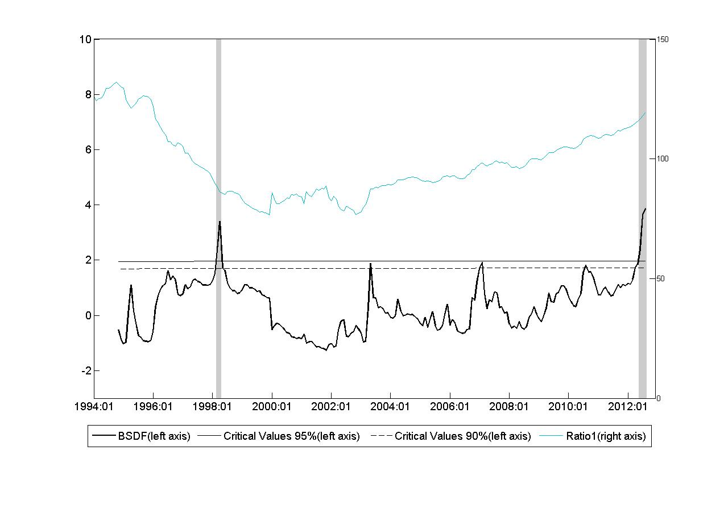

Figure 4 shows that more bubbles are found using Ratio2. However, it coincides with Figure 3 in showing that currently the Colombian housing prices are experiencing a positive bubble. Our findings should be considered as the result of using a new method for price-bubble detection on a housing-price sample. For potential policy implications additional results found by studies using alternative methodologies should also be considered.

Figure 4: BSDF for Ratio2
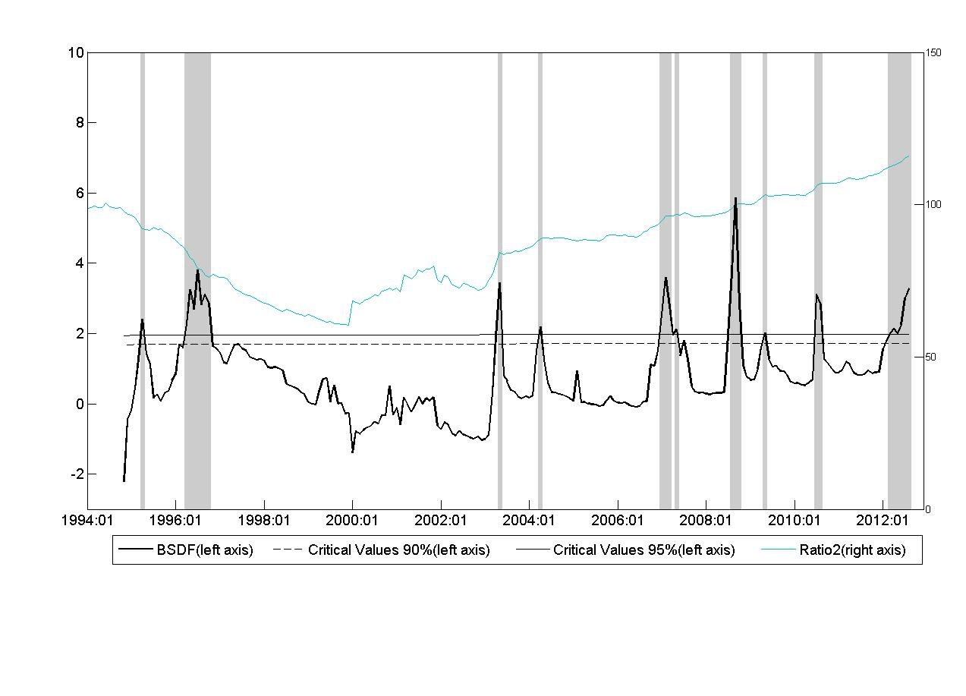

5. Conclusion
This article performs the Phillips et al (2012) test and shows that Colombia may be experiencing a housing-price bubble. This evidence contrasts with recent works employing traditional bubble-detection methodologies. Furthermore, we also obtain evidence of an earlier bubble in the late 1990s which could have triggered the financial crisis that Colombia experimented at that time.
Some caveats apply to our results. First, we are not able to check the robustness of our results to alternative deflators, such as a household income index and a land price index, due to the lack of monthly data on these indicators. And, second, in this study we implement a univariate detection test which does not consider a structural model of supply and demand for housing. Following the tradition of unit-root and cointegration tests, the methodology we implement works under the I(1) null hypothesis based on the theory of efficient markets, where asset prices follow a random walk reflecting the assumption that only new information affects each period’s current asset prices. We acknowledge that methodologies based on alternative theories should be considered in order to confirm the results shown in this paper.

References
Arshanapalli, B. and W. Nelson, 2008, “A co-integration test to verify the housing bubble”, The International Journal of Business and Finance Research, 2, No. 2, 35-43.

Campbell, J. and R. Shiller, 1987, “Co-integration and tests of present value models”, Journal of Political Economy, 95, 1062-1088.

Diba, B. and H. Grossman, 1988, “Explosive rational bubbles in stock prices”, American Economic Review, 78, 520 530.

Drake, L., 1993, “Modelling UK house prices using co-integration: An application of the Johansen technique”, Applied Economics, 25, 1225-1228.

Evans, G., 1991, “Pitfalls in testing for explosive bubbles in asset prices”, American Economic Review, 81, 922-930.

Phillips, P.C.B., Y. Wu and J. Yu, 2011, “Explosive behavior in the 1990s Nasdaq: When did exuberance escalate asset values?”, International Economic Review, 52, 201-226.
Phillips, P.C.B., S. Shi, and Yu, J., 2012, “Testing for multiple bubbles”. Cowles Foundation Discussion Paper No 1843.

Salazar, N., Steiner, R., Becerra, A. y Ramírez, J. 2013. “Los efectos del precio del suelo sobre el precio de la vivienda para Colombia”; Ensayos Sobre Política Económica. Forthcoming.
Shiller, R., 1981, “Do stock prices move too much to be justified by subsequent changes in dividends?” American Economic Review, 71, 421-436.

West, K., 1987, “A specification test for speculative bubbles”, The Quarterly Journal of Economics, 102, 553-580.

Yiu, M., Yu, J. and Jin, L., 2012, “Detecting bubbles in Hong Kong residential property market”. Hong Kong Institute for Monetary Research. Working Paper No. 1/2012.

Disclaimer: The findings, recommendations, interpretations and conclusions expressed in this paper are those of the authors and do not necessarily reflect the view of the Banco de la República or its Board of Directors. We gratefully acknowledge Peter C.B. Phillips, Jun Yu, Hernando Vargas and Andrés Murcia for valuable comments. All remaining errors are our own.
The authors are, respectively, Senior Research Economist, Research Economist, Research Assistant and Research Assistant pertaining to the Research Department of the Central Bank of Colombia. Emails of the authors are: jgomezgo@banrep.gov.co; jojedajo@banrep.gov.co; mreyguer@banrep.gov.co; nsicares@banrep.gov.co
This data corresponds to monthly price changes of new houses in Bogotá.
Our findings should be considered as the result of using a new method for price-bubble detection on a housing-price sample. For potential policy implications additional results found by studies using alternative methodologies should also be considered.

